Impact of Selected International HRM Practices on Expatriate Job Performance at ABC (Pvt) Ltd Sri Lanka.

MBAD/2021009

V.J Pussella

# CHAPTER FIVE

# Data Presentation and Analysis

# 5.1 Introduction

This chapter discuss the data presentation and analysis. The data were analyzed by using descriptive statistic software SPSS version 22 to discuss the impact of independent variable (International Human Resource Practices) on the dependent variable (Expatriates Job Performance). Furthermore, explain the bivariate analysis with correlation and regression analysis and finally explain the summary.

# 5.2 Analysis of Reliability of the Instruments

The study has been selected 60 expats in ABC Pvt Ltd Sri Lanka as the sample. The particular two tests were carried out using 30 respondents. The inter item consistency reliability was examined with Cronbach’s Alpha test. This test was carried out using 30 responses from ABC Pvt Ltd Sri Lanka. The result of Cronbach’s Alpha test is given in Table 5.1 which suggest that internal reliability of each instrument is satisfactory.

*Table 5. 1: Cronbach’s Alpha*

|  |  |
| --- | --- |
| **Instrument** | **Cronbach’s Alpha** |
| International Human Resource Practices | 0.894 |
| Expatriates Job Performance | 0.841 |

The responses of respondents were scored, and the reliability of the study was determined using Cronbach’s Alpha. (Connelly, 2011) stated that according to the alpha value more than 0.7 shows that the scale can be considered reliable. The questionnaire has 32 questions, 20 questions for international human resource practices and 7 questions for expatriate job performance. The results show that the Cronbach’s Alpha as international human resource 0.894 and expatriate job performance 0.841. Therefore, it can mention that the scale is reliable.

# 5.3 Analysis of Validity of the Instruments

As mentioned in (Hadi,2016) KMO is used to measure the sample adequacy and if the KMO value is above 0.5 the sample is adequate and sufficient. KMO and Bartlett's test results of the current study are presented in Table 5.2

|  |  |  |  |
| --- | --- | --- | --- |
| **Variables** | **Items** | **KMO>0.5** | **Bartlett's Test of Sphericity (P<0.05)** |
| International Human resource Practices | 20 | 0.715 | 0.000 |
| Expatriates job performance | 7 | 0.787 | 0.000 |

With reference to the Table 5.2, the value of KMO were above the cut-off point which indicates a good range of sample adequacy and the values of construct s were significant according to Bartlett's Sphericity Test.

# 5.4 Univariate Analysis

This section explains frequency distribution analysis of respondents by their demographic characteristics, frequency distribution analysis for IHRM practices and expatriates job performance.

## 5.4.1 Frequency Distribution Analysis of Respondents by Their Demographic Characteristics

This section analyses the personal characteristics of respondents’ data, which were collected from questionnaires. The data were collected on the following personal characteristics of respondents.

* Gender
* Age
* Working experience
* Job title
* Nationality

### 5.4.1.1 Gender

The questionnaire was distributed among both male and female employees. As shown in the Table 5.3 and Figure 5.2, out of the 60 respondents, 34 respondents are male, and 26 respondents are female employees. Therefore, 56% of the respondents are male while 43% respondents are female.

*Table 5. 2: Gender Distribution*

|  |  |  |
| --- | --- | --- |
| **Gender** | **Frequency** | **Percentage** |
| Male | 34 | 56 |
| Female | 26 | 43 |
| Total | 60 | 100 |

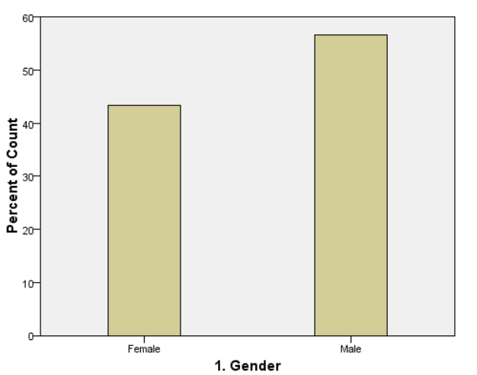

*Figure 5. 1: Gender Distribution*

### 5.4.1.2 Age

The whole duration of a being is considered as the age of a person (Table 5.4). It was represented the age group of between 20-26, which is 6 employees. Expatriates who are between 27-32 years are the highest age category, which is 26 employees. 26 sample of employees represented age group between 33-39. Employees who are above 40 years are the lowest age category, which is 2 employees.

*Table 5. 3: Age Distribution of Expatriates*

|  |  |  |
| --- | --- | --- |
| **Age** | **Frequency** | **Percentage** |
| 20-26 | 6 | 10 |
| 27-32 | 26 | 43 |
| 33-39 | 26 | 43 |
| 40 or over | 2 | 3 |
| Total | 60 | 100 |

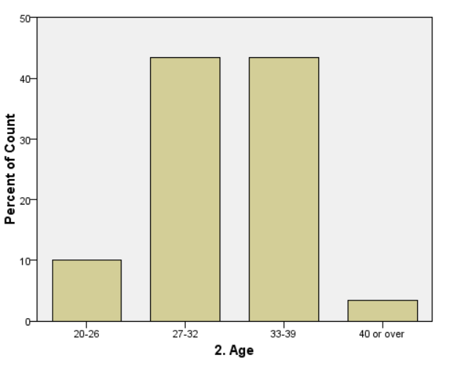

*Figure 5. 2: Age Distribution of Expatriates*

### 5.4.1.3 Work Experience

The whole years of working for and organization is considered as the experience of expatriates. There were four categories that were used for this study. The data found that majority of respondents were in year 5 category with 18% approximately and minority of the respondents were in the 1, 6.5,9,13,14,24,25 years range. This experience distribution clearly can be identified by following Table.

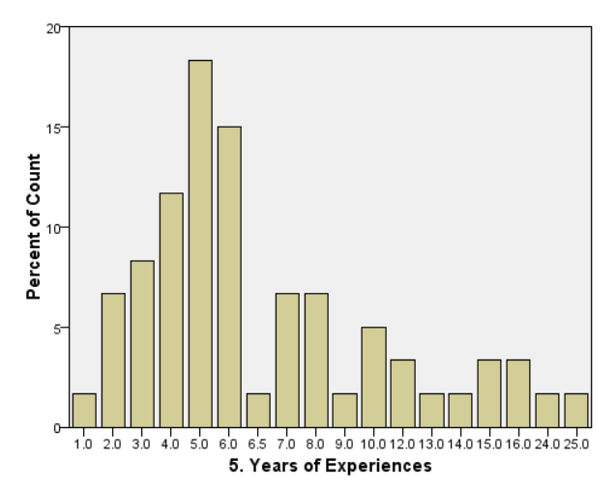 *Table 5. 4: Working Experience*

*Figure 5. 3: Working Experiences*

|  |  |  |
| --- | --- | --- |
| **Years of Experience** | **Count** | **Percentage** |
| 1 | 1 | 1 |
| 2 | 4 | 6 |
| 3 | 5 | 8 |
| 4 | 7 | 11 |
| 5 | 11 | 18 |
| 6 | 9 | 15 |
| 6.5 | 1 | 1 |
| 7 | 4 | 6 |
| 8 | 4 | 6 |
| 9 | 1 | 1 |
| 10 | 3 | 5 |
| 12 | 2 | 3 |
| 13 | 1 | 1 |
| 14 | 1 | 1 |
| 15 | 2 | 3 |
| 16 | 2 | 3 |
| 24 | 1 | 1 |
| 25 | 1 | 1 |

### 5.4.1.4 Job Title

Table 5.5 and Figure 5.4 explains about job titles of selected sample. There were twenty-four categories that used for this study. The data found that majority of respondents were in wireless engineer 18% approximately and minority of the respondents were in several categories with 1%.

*Table 5.5 Job Title*

|  |  |  |
| --- | --- | --- |
| **Job Titles** | **Count** | **Percentage** |
| Accountant | 1 | 1 |
| Civil Engineer | 4 | 6 |
| Core Network Engineer | 1 | 1 |
| Data Analyst | 2 | 3 |
| Datacom Engineer | 4 | 6 |
| Legal Officer | 1 | 1 |
| Product Configuration Engineer | 2 | 3 |
| Project Coordinator | 5 | 8 |
| Project Director | 4 | 6 |
| Project Manager | 6 | 10 |
| Regional Project Manager | 2 | 3 |
| RF Engineer | 4 | 6 |
| Senior Engineer | 2 | 3 |
| Senior Project Coordinator | 1 | 1 |
| Solution Engineer | 2 | 3 |
| Solutions Engineer | 1 | 1 |
| Specialist RF | 1 | 1 |
| Specialist WL | 3 | 5 |
| Technical Director | 2 | 3 |
| Vice President Project | 1 | 1 |
| Wireless Engineer | 11 | 18 |

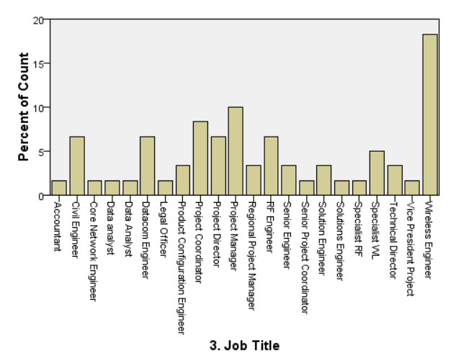5.4.1.5 Nationality

*Figure 5.4 Job Titles*

Table 5.6 explains about nationalities of selected sample. There were six categories that used for this study. The data found that majority of respondents were in Chinese 48% approximately and the minority of the respondents were in Malaysians with 3%.

*Table 5.6 Nationality*

|  |  |  |
| --- | --- | --- |
| **Nationality** | **Count** | **Percentage** |
| Chinese | 29 | 48 |
| Indian | 16 | 26 |
| Malaysian | 2 | 3 |
| Nepalis | 6 | 10 |
| Pakistani | 3 | 5 |
| Thai | 4 | 6 |

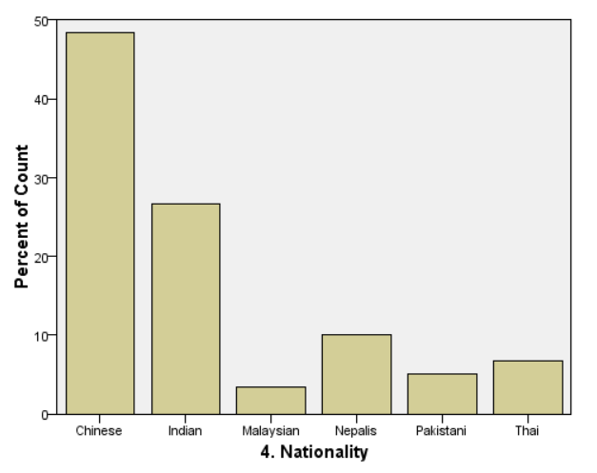

*Figure 5.5 Nationalities*

# 5.5 Frequency Distribution Analysis for International Human Resource Management Practices and Expatriates Job Performance

The frequency distribution analysis was made individually for the variables of International HRM practices and expatriates job performance. The frequency distributions are presented in the table and the result have been interpreted mainly considering the skewness and Kurtosis of the distribution.

## 5.5.1 Frequency Distribution Analysis for International HRM Practices

As indicated by Table 5.7, the mean value of the distribution is 3.4125. Then the IHRMP of the respondents is “Neutral”. The skewness and kurtosis of the distribution are -0.238 and -0.078, which indicated that the data recorded for the International HRM Practices are slightly negatively skewed lighted tails compared to the normal distribution.

And also, the mean value of the distribution of international training and development, international compensation and international performance appraisals can be stated as 3.65, 3.2167and 3.4361respectively. Statistics of the distribution of IHRMP and its dimensions are indicated in following Table 5.7.

*Table 5.7 Statistics of the Distribution of International HRM Practices*

|  |  |  |  |  |
| --- | --- | --- | --- | --- |
| **Statistic** | **International Training & Development** | **International Compensation** | **International Performance Appraisals** | **International HRM Practices** |
| Mean Std. Error | 0.11863 | 0.12591 | 0.10474 | 0.07984 |
| Mean | 3.65 | 3.2167 | 3.4361 | 3.4125 |
| 5% Trimmed Mean | 3.6852 | 3.2222 | 3.429 | 3.4194 |
| Median | 3.8333 | 3.125 | 3.5 | 3.5 |
| Variance | 0.844 | 0.951 | 0.658 | 0.383 |
| Std. Deviation | 0.91889 | 0.9753 | 0.81134 | 0.61847 |
| Minimum | 1 | 1 | 2 | 2.1 |
| Maximum | 5 | 5 | 5 | 5 |
| Range | 4 | 4 | 3 | 2.9 |
| Interquartile Range | 0.83 | 1.5 | 1 | 0.84 |
| Skewness | -0.627 | -0.146 | -0.219 | -0.238 |
| Kurtosis | 0.303 | -0.592 | -0.318 | -0.078 |

## 5.5.2Frequency Distribution Analysis for Expatriates Job Performance

As indicated by Table 5.11, the mean value of the distribution is 3.8690. Then the expatriates job performance the respondents is “satisfied”. The skewness and kurtosis of the distribution are 0.005 and -0.339, which indicated that the data recorded for the expatriate’s job performance are almost symmetrical and lighted tails compared to the normal distribution, fewer extreme values.

And also, the mean value of the distribution of task performance and contextual performance can be stated as 3.9167 and 3.8056 respectively. Statistics of the distribution of expatriate’s job performance and its dimensions are indicated in below table 5.8.

*Table 5.8 Statistics of the Distribution of Expatriates Job Performance*

|  |  |  |  |
| --- | --- | --- | --- |
| **Statistics** | **Task Performance** | **Contextual Performance** | **Expatriates Job Performance** |
| Mean Std. Error | .09812 | .09044 | .07395 |
| Mean | 3.9167 | 3.8056 | 3.8690 |
| 5% Trimmed Mean | 3.9491 | 3.8025 | 3.8651 |
| Median | 4.0000 | 4.0000 | 4.0000 |
| Variance | .578 | .491 | .328 |
| Std. Deviation | .76006 | .70053 | .57281 |
| Minimum | 2.00 | 2.00 | 2.43 |
| Maximum | 5.00 | 5.00 | 5.00 |
| Range | 3.00 | 3.00 | 2.57 |
| Interquartile Range | 1.19 | 1.00 | .71 |
| Skewness | -.292 | .036 | .005 |
| Kurtosis | -.387 | -.421 | -.339 |

# 5.6 Examine the Factors of Variables

This section explains importance of the determinants of the independent variable (IHRP) and dependent variables (expatriates job performance) of the study.

## 5.6.1 Examine the Determinants of International Human Resource Practices

This section explains the importance of dimensions (International Training & Development, International Compensation and International Performance Appraisal) of International Human Resource Practices. Following Table 5.9 shows the importance of dimensions of IHRP by ranking them according to the mean value.

*Table 5.9 Ranking the Dimensions of International Human Resource Practices*

|  |  |  |  |
| --- | --- | --- | --- |
| **Dimension** | **Mean** | **Std. Deviation** | **Rank** |
| Training & Development | 3.6500 | 0.91889 | 1 |
| Performance Appraisals | 3.4361 | 0.81134 | 2 |
| Compensation | 3.2167 | 0.9753 | 3 |

According to mean value of each dimension training & development is the most important dimension of International human resource practices. Other dimensions can be ordered as, performance appraisals and compensation in respectively.

## 5.6.2 Examine the Determinants of Expatriates Job Performance

This section explains the importance of dimensions (task performance and contextual performance) of expatriate’s job performance. Following Table 5.10 shows the importance of dimensions of by ranking them according to the mean value.

*Table 5.10: Ranking the Dimensions of Job Performance*

|  |  |  |  |
| --- | --- | --- | --- |
| **Dimension** | **Mean** | **Std. Deviation** | **Rank** |
| Task Performance | 3.9167 | 0.76006 | 1 |
| Contextual Performance | 3.8056 | 0.70053 | 2 |

According to mean value of each dimension task performance is the most important dimension of expatriate’s job performance.

# 5.7 Hypotheses Testing

The hypotheses testing was carried using the results of Pearson’s product movement correlation analysis and the results of regression analysis.

## 5.7.1 Testing Hypothesis H1

The hypothesis 1 was;

## H1: There is a significant impact of IHRM Practices on expatriate’s job performance

Analysis of correlation was used to determine the relationship between independent variable and dependent variable of the study. The objective is to check whether there is a relationship between the variables; IHRMP and expatriates job performance. The observed Pearson correlation coefficient is 0.3, according to Table 5.11 implying that a positive relationship occurs between the international human resource practices and expatriates job performance.

Additionally, regression analysis was used to find out the impact in between independent variable and dependent variable.

*Table 5. 11 Correlation between IHRMP and Expatriates Job Performance*

|  |  |  |  |
| --- | --- | --- | --- |
| **Correlations** | | | |
|  | | Expatriates Job Performance | International Human Resource Practices |
| Expatriates Job Performance | Pearson Correlation | 1 | .300* |
| Sig. (2-tailed) |  | .020 |
| N | 60 | 60 |
| International Human Resource Practices | Pearson Correlation | .300* | 1 |
| Sig. (2-tailed) | .020 |  |
| N | 60 | 60 |
| *. Correlation is significant at the 0.05 level (2-tailed). | | | |

The outcomes show (Table 5.12) that the regression coefficients (R) of the International human resource practices related independent variable and job performance was 0.300 and the R Square was 0.090. It indicates that about 9 percent of the variance (R Square) in the expatriate’s job performance is explicated by IHRMP.

*Table 5. 12 Regression Analysis of Employee Engagement and Job Performance (Model Summary)*

|  |  |  |  |  |  |  |  |  |  |
| --- | --- | --- | --- | --- | --- | --- | --- | --- | --- |
| **Model Summary** | | | | | | | | | |
| Model | R | R Square | Adjusted R Square | Std. Error of the Estimate | Change Statistics | | | | |
| R Square Change | F Change | df1 | df2 | Sig. F Change |
| 1 | .300a | .090 | .074 | .55119 | .090 | 5.720 | 1 | 58 | .020 |
| a. Predictors: (Constant), International Human Resource Practices | | | | | | | | | |
| b. Dependent Variable: Expatriates Job Performance | | | | | | | | | |

The p-value is below 0.05. Which ensures which IHRMP can be used to forecast expatriates job performance (refer Table 5.13).

*Table 5. 13: ANOVA*

|  |  |  |  |  |  |  |
| --- | --- | --- | --- | --- | --- | --- |
| **ANOVAa** | | | | | | |
| Model | | Sum of Squares | df | Mean Square | F | Sig. |
| 1 | Regression | 1.738 | 1 | 1.738 | 5.720 | .020b |
| Residual | 17.621 | 58 | .304 |  |  |
| Total | 19.359 | 59 |  |  |  |
| a. Dependent Variable: Expatriates Job Performance | | | | | | |
| b. Predictors: (Constant), International Human Resource Practices | | | | | | |

*Table 5. 14: Coefficient*

|  |  |  |  |  |  |  |
| --- | --- | --- | --- | --- | --- | --- |
| **Coefficients** | | | | | | |
| Model | | Unstandardized Coefficients | | Standardized Coefficients | t | Sig. |
| B | Std. Error | Beta |
| 1 | (Constant) | 2.922 | .402 |  | 7.264 | .000 |
| International Human Resource Practices | .277 | .116 | .300 | 2.392 | .020 |
| a. Dependent Variable: Expatriates Job Performance | | | | | | |

According to the result shown in Table 5.14, the β value for the International human resource practices is 0.277. It indicates that there is a positive impact on international human resource practices and expatriates job performance. It can be further said, if IHRMP increases by one unit, expatriates job performance will be increased by 0.277. It is significant since the p value is 0.020, it is less than 0.05. Hence it can be proved that there is a positive impact on international human resource practices on expatriate’s job performance in ABC Pvt Ltd, Sri Lanka.

## 5.7.2 Testing Hypothesis H2

The hypothesis 2 was;

## H2: There is a significant impact of International Training and development practices on expatriate’s job performance.

Following table 5.15 shows the correlation between international training & development and expatriates job performance.

*Table 5. 15: Correlation between Training and Development and Expatriates Job Performance*

|  |  |  |  |
| --- | --- | --- | --- |
| **Correlations** | | | |
|  | | Expatriates Job Performance | International Training & Development |
| Expatriates Job Performance | Pearson Correlation | 1 | .292* |
| Sig. (2-tailed) |  | .024 |
| N | 60 | 60 |
| International Training & Development | Pearson Correlation | .292* | 1 |
| Sig. (2-tailed) | .024 |  |
| N | 60 | 60 |
| *. Correlation is significant at the 0.05 level (2-tailed). | | | |

Based on Pearson movement correlation findings (Table 5.15) for two variables is 0.292 which discovered that there is a positive connection between international training & development and job performance of expats in the ABC Pvt Ltd, Sri Lanka. Also, a significant relationship between these two variables can be statistically claimed: training & development and expatriates job performance.

Additionally, regression analysis was also conducted to assess the impact of international training and development on expatriate’s job performance.

The results show (Table 5.16) that the regression coefficients (R) of the international training and development and the expatriates job performance was 0.292 and the R Square was 0.085. It indicates that about 8.5 percent of the variance (R Square) in the expatriate’s job performance is explicated by international training and development.

*Table 5. 16: Model Summary H2*

|  |  |  |  |  |  |  |  |  |  |
| --- | --- | --- | --- | --- | --- | --- | --- | --- | --- |
| **Model Summary** | | | | | | | | | |
| Model | R | R Square | Adjusted R Square | Std. Error of the Estimate | Change Statistics | | | | |
| R Square Change | F Change | df1 | df2 | Sig. F Change |
| 1 | .292a | .085 | .069 | .55260 | .085 | 5.396 | 1 | 58 | .024 |
| a. Predictors: (Constant), Training & Development | | | | | | | | | |
| b. Dependent Variable: Expatriates Job Performance | | | | | | | | | |

The p-value is below 0.05. Which ensures which training and development can be used to forecast expats job performance (refer Table 5.17).

*Table 5. 17: ANOVAa H2*

|  |  |  |  |  |  |  |
| --- | --- | --- | --- | --- | --- | --- |
| **ANOVAa** | | | | | | |
| Model | | Sum of Squares | df | Mean Square | F | Sig. |
| 1 | Regression | 1.648 | 1 | 1.648 | 5.396 | .024b |
| Residual | 17.711 | 58 | .305 |  |  |
| Total | 19.359 | 59 |  |  |  |
| a. Dependent Variable: Expatriates Job Performance | | | | | | |
| b. Predictors: (Constant), International Training & Development | | | | | | |

*Table 5. 18: Coefficients H2*

|  |  |  |  |  |  |  |
| --- | --- | --- | --- | --- | --- | --- |
| **Coefficients** | | | | | | |
| Model | | Unstandardized Coefficients | | Standardized Coefficients | t | Sig. |
| B | Std. Error | Beta |
| 1 | (Constant) | 3.137 | .323 |  | 9.716 | .000 |
| International Training & Development | .199 | .086 | .292 | 2.323 | .024 |
| a. Dependent Variable: Expatriates Job Performance | | | | | | |

Accordingly, regression equation of expats job performance in ABC Pvt Ltd, Sri Lanka is: Expatriates Job Performance = 3.137+0.199 (International Training & Development).

## 5.7.3 Testing Hypothesis H3

The hypothesis 3 was;

## H3: There is a significant impact of International Performance Appraisal practices on expatriate’s job performance.

Following table 5.19 shows the correlation international performance appraisals and expatriates job performance.

*Table 5. 19 Correlation between international performance appraisals and expats Job Performance*

|  |  |  |  |
| --- | --- | --- | --- |
| **Correlations** | | | |
|  | | Expatriates Job Performance | Performance Appraisals |
| Expatriates Job Performance | Pearson Correlation | 1 | .273* |
| Sig. (2-tailed) |  | .035 |
| N | 60 | 60 |
| Performance appraisals | Pearson Correlation | .273* | 1 |
| Sig. (2-tailed) | .035 |  |
| N | 60 | 60 |
| *. Correlation is significant at the 0.05 level (2-tailed). | | | |

Based on Pearson movement correlation findings (Table 5.19) for two variables is 0.273 which discovered that there is a positive connection between international performance appraisals and expatriates job performance of executives in ABC Pvt Ltd, Sri Lanka. Also, a significant relationship between these two variables can be statistically claimed: International performance appraisals and expatriates job performance.

Additionally, regression analysis was also conducted to assess the impact of: International performance appraisals on expatriate’s job performance.

The results show (Table 5.20) that regression coefficients (R) of the international performance appraisals and the expatriates job performance was 0.273 and the R Square was 0.074. It indicates that about 7.4 percent of the variance (R Square) in the expatriate’s job performance is explicated by international performance appraisals.

*Table 5. 20: Model Summary H3*

|  |  |  |  |  |  |  |  |  |  |
| --- | --- | --- | --- | --- | --- | --- | --- | --- | --- |
| **Model Summary** | | | | | | | | | |
| Model | R | R Square | Adjusted R Square | Std. Error of the Estimate | Change Statistics | | | | |
| R Square Change | F Change | df1 | df2 | Sig. F Change |
| 1 | .273a | .074 | .058 | .55585 | .074 | 4.655 | 1 | 58 | .035 |
| a. Predictors: (Constant), International performance appraisals | | | | | | | | | |
| b. Dependent Variable: Expatriates Job Performance | | | | | | | | | |

The p-value is below 0.05. Which ensures which international performance appraisals can be used to forecast expatriates job performance (refer Table 5.21).

*Table 5. 21: ANOVAa H3*

|  |  |  |  |  |  |  |
| --- | --- | --- | --- | --- | --- | --- |
| **ANOVAa** | | | | | | |
| Model | | Sum of Squares | df | Mean Square | F | Sig. |
| 1 | Regression | 1.438 | 1 | 1.438 | 4.655 | .035b |
| Residual | 17.920 | 58 | .309 |  |  |
| Total | 19.359 | 59 |  |  |  |
| a. Dependent Variable: Expatriates Job Performance | | | | | | |
| b. Predictors: (Constant), International Performance and Evaluation | | | | | | |

*Table 5. 22: Coefficients H3*

|  |  |  |  |  |  |  |
| --- | --- | --- | --- | --- | --- | --- |
| **Coefficients** | | | | | | |
| Model | | Unstandardized Coefficients | | Standardized Coefficients | t | Sig. |
| B | Std. Error | Beta |
| 1 | (Constant) | 3.208 | .315 |  | 10.191 | .000 |
| Performance Appraisals | .192 | .089 | .273 | 2.158 | .035 |
| a. Dependent Variable: Expatriates Job Performance | | | | | | |

Accordingly, regression equation of expatriate’s job performance in ABC Pvt Ltd, Sri Lanka is: Expatriates Job Performance = 3.208 +0.192 (International Performance Appraisals).

## 5.7.4 Testing Hypothesis H4

The hypothesis 4 was;

## H4: There is a significant impact of International Compensation on expatriate’s job performance.

Following table 5.23 shows the correlation between international compensation and expatriates job performance.

*Table 5. 23: Correlation between International Compensation and Job Performance*

|  |  |  |  |
| --- | --- | --- | --- |
| **Correlations** | | | |
|  | | Expatriates Job Performance | Compensation |
| Expatriates Job Performance | Pearson Correlation | 1 | .311* |
| Sig. (2-tailed) |  | .016 |
| N | 60 | 60 |
| International Compensation | Pearson Correlation | .311* | 1 |
| Sig. (2-tailed) | .016 |  |
| N | 60 | 60 |
| *. Correlation is significant at the 0.05 level (2-tailed). | | | |

Based on Pearson movement correlation findings (Table 5.23) for two variables is 0.311 which discovered that there is a positive connection between international compensation and expatriates job performance of ABC Pvt Ltd, Sri Lanka. Also, a significant relationship between these two variables can be statistically claimed: International compensation and expatriates job performance.

Additionally, regression analysis was also conducted to assess the impact of international compensation on expatriate’s job performance.

The results show (Table 5.24) that the regression coefficients (R) of the international compensations and the expatriates job performance was 0.311 and the R Square was 0.096. It indicates that about 9.6 percent of the variance (R Square) in the expatriate’s job performance is explicated by international compensation.

*Table 5. 24: Model Summary H4*

|  |  |  |  |  |  |  |  |  |  |
| --- | --- | --- | --- | --- | --- | --- | --- | --- | --- |
| **Model Summary** | | | | | | | | | |
| Model | R | R Square | Adjusted R Square | Std. Error of the Estimate | Change Statistics | | | | |
| R Square Change | F Change | df1 | df2 | Sig. F Change |
| 1 | .311a | .096 | .081 | .54915 | .096 | 6.193 | 1 | 58 | .016 |
| a. Predictors: (Constant), Compensation | | | | | | | | | |
| b. Dependent Variable: Expatriates Job Performance | | | | | | | | | |

The p-value is below 0.05. Which ensures which international compensation can be used to forecast expatriates job performance (refer Table 5.25).

*Table 5. 25: ANOVAa H4*

|  |  |  |  |  |  |  |
| --- | --- | --- | --- | --- | --- | --- |
| **ANOVAa** | | | | | | |
| Model | | Sum of Squares | df | Mean Square | F | Sig. |
| 1 | Regression | 1.868 | 1 | 1.868 | 6.193 | .016b |
| Residual | 17.491 | 58 | .302 |  |  |
| Total | 19.359 | 59 |  |  |  |
| a. Dependent Variable: Expatriates Job Performance | | | | | | |
| b. Predictors: (Constant), International Compensation | | | | | | |

*Table 5. 29: Coefficients H4*

|  |  |  |  |  |  |  |
| --- | --- | --- | --- | --- | --- | --- |
| **Coefficients** | | | | | | |
| Model | | Unstandardized Coefficients | | Standardized Coefficients | t | Sig. |
| B | Std. Error | Beta |
| 1 | (Constant) | 3.282 | .246 |  | 13.330 | .000 |
| Compensation | .182 | .073 | .311 | 2.489 | .016 |
| a. Dependent Variable: Expatriates Job Performance | | | | | | |

Accordingly, regression equation of expats job performance ABC Pvt Ltd, Sri Lanka is: Expatriates Job Performance = 3.282+0.182 (International Compensation).

# Summary

This chapter discussed the data presentation and analysis. The data were analyzed by using descriptive statistic software SPSS version 22 to discuss the impact of independent variable (International Human Resource Practices) on the dependent variable (Expatriates Job Performance). Furthermore, the chapter explained the bivariate analysis with correlation and regression analysis finally.